Final Project Report: HuffPost News Category Classification

Jenny James, Sergey Nelyapanko, & Lexi Fortuna
DX703-O1 (Spring 2026) - Advanced Machine Learning and AI
Faculty of Computing & Data Sciences, Boston University
Professor Wayne Snyder
April 26, 2026

B.1 Introduction and Problem Definition
B.1.1 Problem Description and Motivation
We are in the heart of the digital age and online news continues to be on the rise and the way most people get their daily news. This has generated a need for an efficient and accurate system to be able to categorize news articles. With that system being in place, improvements to online search results and recommendations can be put in place, which in-turn improves user experience because they can easily find what they are looking for. News platforms post hundreds, if not thousands of articles everyday covering just about any topic you can think of. This contributes to manual categorization no longer being feasible due to time-constraints and possible inconsistencies.
B.1.2 Project Goals in Both Business and Data-Science Terms
In the business realm, this project supports the need of increasing user engagement and retention. By automating article categorization at scale, this allows for a reliable and accurate system to handle thousands of articles per day. The quicker users find the articles they are looking for, increases the likelihood of more time spent on the platform which means more of a chance the user is looking through the more accurate recommended articles.
In data science terms, this project is predicting the category a news article belongs to from a predefined list of categories. A constraint of this prediction model is that article headlines and descriptions sometimes only provide short text inputs which gives the model very limited context. Another constraint that should be considered is the balance of the training dataset, that can make or break the model when scaling up for real-world use.

B.1.3 Dataset Description
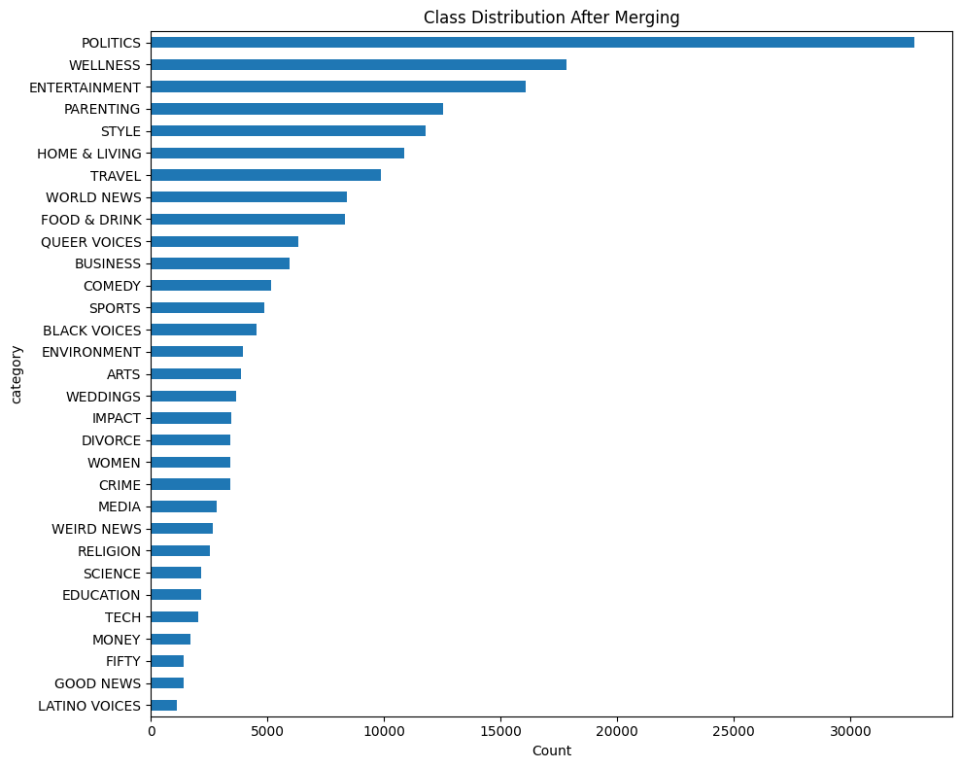
The dataset used in this model analysis is the HuffPost News Category Dataset, obtained from Hugging Face. This dataset consists of news articles published by HuffPost between the years of 2012 and 2018. The raw dataset contains 200,853 records, 41 unique features, and six attributes: Category, Headline, Authors, Link to the Article, Short Description, and Date. After exploratory data analysis was performed, the dataset was found to have substantial overlap among several categories. To address this several categories were merged and resulted in a reduced set of 31 distinct classes. The class distribution is visualized in Figure 1. The largest category, Politics, contains 32,721 articles while the smallest category, Latino Voices, contains only 1,129 articles. This displays a severe class imbalance, but the median class size was found to be lower than the mean which is indication of long-tailed distribution with a lot of underrepresented categories. For more information on the exploratory data analysis (EDA), please see Appendix A.
Figure 1. Class distribution following EDA
B.2 Methodology
B.2.1 Preprocessing Pipeline
Prior to the building of the final model, each sample’s text was formed by concatenating the headline and short_description with a [SEP] separator. When the description was missing (9.98% of records), the headline alone was used. A TextVectorization layer was configured with max_tokens=20,000 and output_sequence_length=64. This was chosen based on the computed P95 word count of 57 words. The layer was adapted on training text only, then applied once to produce integer-encoded numpy arrays (shape 160,290 x 64), avoiding repeated tokenization during training. No text augmentation was applied at this stage. The Hugging Face AutoTokenizer for DistilBERT was utilized with padding and truncation. Class weights were computed using sklearn.compute_class_weight(“balanced”) which produced weights from 0.198 (Politics) to 5.726 (Latino Voices) further supporting the evidence of severe class imbalance.
B.2.2 Model Architecture and Justification
The model that performed the best was DistilBERT (distilbert-base-uncased). This is a distilled version of BERT that retains 97% of BERT’s language understanding while being 40% faster and 60% faster. When experimenting with other BERT models, such as BERT and RoBERTa, they were found to be too heavy for the available computing budget and the short-text classification task the model is accomplishing. What makes DistilBERT a practical choice for this dataset is that it stabilizes faster and does not need as many epochs to reach an acceptable validation performance. Since DistilBERT is a pretrained model, only 2 adaptations were made. Since this is a Hugging Face dataset, TFDistilBertForSequenceClassification class with num_labels=31 was used and the masked language model head was replaced with the following classification head: Pre-classifier(786, 786) + Classifier(786, 31).
B.2.3 Training Strategy
Table 1 below covers all specific training configurations used on the DistilBERT model. Concretely, the model was trained with the AdamW optimizer (weight decay 0.01) using a 2e-5 peak learning rate on a cosine schedule with 10% linear warmup, batch size 128, max sequence length 64, and sparse categorical cross-entropy loss. Early stopping monitored validation loss with patience=2 and restored the best weights. Since the task does not require deep syntactic reasoning, the embedding layer and the bottom 4 transformer blocks were frozen, and the top 2 transformer blocks were unfrozen for fine-tuning. This yielded 36 trainable variable tensors (approximately 14.2M trainable parameters out of 66.9M total). The lower layers capture grammatical features which are less relevant for our task; the upper layers capture topical features which are directly relevant; and a small learning rate with cosine decay ensures gentle adaptation for the unfrozen layers without destabilizing the pretrained representations.
Table 1. DistilBERT Specific Training Configurations
Optimizer | Learning Rate | Max Epochs | Batch Size | Early Stopping | Loss | Class Weights
AdamW  (Weight Decay) | 2e-5  (cosine schedule) | 24 | 128 | Yes  (patience=2) | Sparse Categorical Crossentropy | Yes

B.2.4 Performance Validation
For the final submission the DistilBERT model was trained on the full training set (160,290 samples). Training ran for 24 scheduled epochs with early stopping (patience=2), which triggered at epoch 11; the best validation loss was at epoch 9. Total training time was about 111 minutes on a T4 GPU. Class weights were set to balanced. Full fine-tuning was ruled out because it tends to overfit the dominant classes and destabilize training on an imbalanced dataset. To avoid data leakage, overlapping categories were merged, empty headlines dropped, and exact duplicates removed before creating the stratified 80/10/10 split.
B.3 Results and Evaluation
B.3.1 Quantitative Results
On the held-out test set (20,037 samples), DistilBERT reached 0.661 accuracy, 0.600 macro-F1 (our primary metric for imbalanced data), and 0.673 weighted-F1. Macro-F1 weights all 31 classes equally regardless of size, which makes it the fairest single-number summary when the largest class (POLITICS, 3,272 test samples) has roughly 29 times the support of the smallest (LATINO VOICES, 113 test samples). A model that simply ignored the long tail of minority categories could still score respectably on plain accuracy; macro-F1 exposes that kind of failure, and the 0.073 gap between weighted-F1 (0.673) and macro-F1 (0.600) is itself a signal that the imbalance is still affecting results. Validation metrics were very close to test (0.666 accuracy, 0.607 macro-F1), which indicates the model generalized consistently and did not overfit to the validation split. Figure 2 summarizes the validation and test metrics side by side. Figure 3 shows the training and validation loss curves across the 11 epochs the model ran before early stopping. Figure 4 is the confusion matrix on the test set. Per-class metrics are in Table 2.
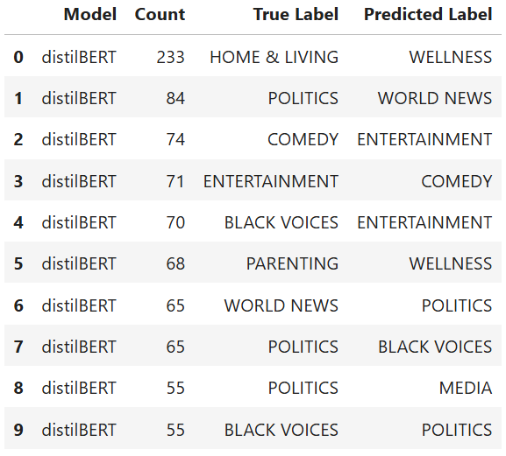
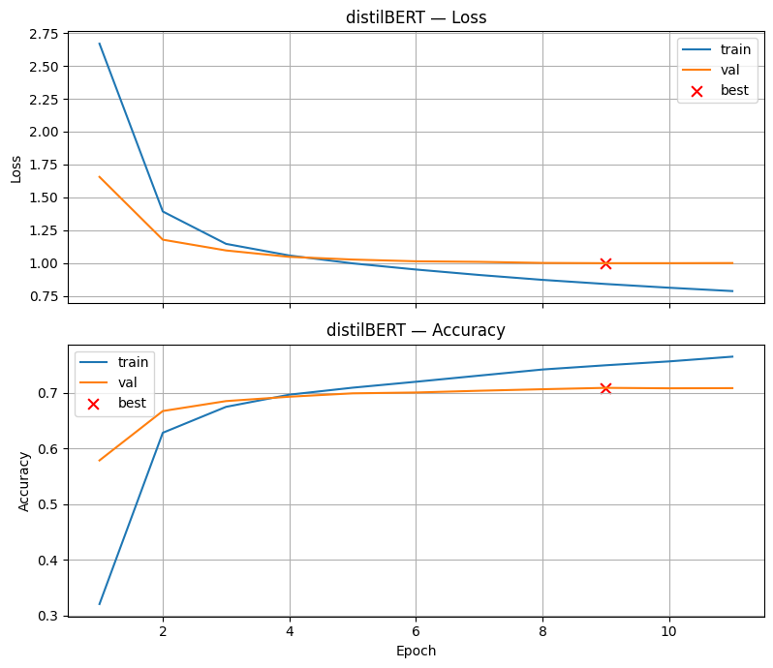
Figure 4. DistilBERT’s confusion matrix for test predictions
Figure 3. DistilBERT training and validation loss curves
B.3.2 Interpretation of Results
The closeness of the test and validation metrics (0.661 vs 0.666 accuracy) points to stable generalization. The gap between weighted-F1 (0.673) and macro-F1 (0.600) is the clearer signal of what is happening under the hood: the model does well on the larger classes and noticeably worse on the smaller ones. POLITICS, STYLE, FOOD & DRINK, TRAVEL, and WELLNESS all land above 0.70 F1, while FIFTY, LATINO VOICES, GOOD NEWS, WOMEN, and IMPACT sit below 0.42. This is consistent with the 29x class imbalance documented earlier.
Figure 3 shows training loss continuing to fall after validation loss plateaus at epoch 9, which is a mild overfitting signal, but early stopping cut training off before it became a problem. Figure 4 highlights the categories the model cannot fully separate. The most frequent confusions on this run were HOME & LIVING to WELLNESS (160), POLITICS to MEDIA (156), POLITICS to WORLD NEWS (133), ENTERTAINMENT to COMEDY (128), and POLITICS to BUSINESS (111). These are almost all genuinely overlapping topics in the HuffPost taxonomy rather than model failures. The dominant class POLITICS also gets split across several related categories, which drags its recall down to 0.57 even though its precision is 0.92, meaning the model is conservative about predicting POLITICS but everything it labels as POLITICS is usually right. This high-precision / low-recall pattern is a direct fingerprint of the class imbalance: with balanced class weights the loss penalizes POLITICS false positives heavily, so the model learns to hold back when it is uncertain, trading recall for precision on the dominant class.
B.3.3 Summary of Final Model Performance
DistilBERT was the strongest model tested. Against the from-scratch models in Milestone 2 (baseline 0.564 test accuracy / 0.499 macro-F1; LSTM, BiLSTM, and Enhanced Baseline all in the same range), DistilBERT improves by roughly 10 percentage points on both accuracy and macro-F1. Its advantage comes from the pretrained contextual embeddings combined with selective fine-tuning of the top two transformer blocks, which together capture semantics in headlines and short descriptions that the simpler models cannot.
On the strength side, no class received zero predictions (every minority class gets at least some correct labels) and per-class F1 improves on all 31 categories relative to the baseline. On the weakness side, the remaining errors cluster around semantically similar categories even after merging overlapping labels (HOME & LIVING and WELLNESS in particular), and the smallest classes still struggle despite class weights. DistilBERT comes at a real computational cost — 67M parameters (~14M trainable) and 111 minutes of training on a T4 GPU compared to under a minute for the from-scratch models — but the performance gain justifies that cost for a task where accuracy matters more than training speed.
B.4 Discussion and Reflection
B.4.1 Limitations and Sources of Error
Five different limitations and sources of error were identified. The first is dataset ambiguity. The most persistent errors (HOME & LIVING vs. WELLNESS, ENTERTAINMENT vs. COMEDY, POLITICS vs. WORLD NEWS / MEDIA / BUSINESS) reflect genuine semantic overlap in the HuffPost editorial taxonomy rather than a model failure. Even DistilBERT's contextual representations could not fully resolve these confusions because the categories themselves are not cleanly separable from short text alone. The second is the short-text constraint: headlines and short descriptions average only about 30 words, which provides limited context for distinguishing between topically related categories. The third limitation is capacity. Under partial fine-tuning (top 2 transformer blocks, about 14M trainable parameters) the full-data run reached 0.661 test accuracy compared to 0.708 on the 50% subset in Milestone 2. Both EPOCHS=16 and EPOCHS=24 schedules produced the same roughly 0.66 result, so this looks like a capacity limitation rather than a learning-rate issue. The fourth limitation is class imbalance; even with balanced class weights, the 29x imbalance ratio still had a substantial impact on minority-class recall. The fifth is limited hyperparameter exploration: given the long training times (about 110 minutes per run), the learning rate, number of unfrozen layers, and epoch count were not systematically tuned.
B.4.2 Potential Improvements
Improvements fall into two broad buckets: what we can do with the data, and what we can do with the model. On the data side, the strongest lever is further category consolidation. The persistent confusions we saw (HOME & LIVING with WELLNESS, ENTERTAINMENT with COMEDY) are not really model failures so much as taxonomy failures, and a second round of merging informed by the actual confusion matrix would give the model a cleaner target. Longer text inputs would help too: switching from headline plus short description to full article bodies would give the model the 100-200 word windows that DistilBERT handles most naturally, rather than the 30-word average we worked with. Minority-class augmentation such as paraphrasing or back-translation is another option, but it is a lower-priority lever than merging and length because the class weights already partially compensate for imbalance.
On the model side, the single most important change is unfreezing more of the transformer. The 50% subset run reached 0.708 test accuracy with only the top 2 blocks trainable; scaling to the full dataset with the same freeze strategy dropped us to 0.661. The most natural reading of that result is that 14M trainable parameters saturate on the larger dataset, and the fix is to give the model more capacity by unfreezing the top 3 or 4 blocks. A proper hyperparameter search (learning rate schedule, number of unfrozen blocks, longer max_length, validation F1 as the optimization criterion) would then be worth running from that stronger baseline rather than from the current one.
B.4.3 Reflection on what you learned
A main takeaway from this project was the importance of fine tuning a pretrained model. DistilBERT performed well for only being partially fine-tuned, but computational power could have been saved based on earlier stopping or a more refined scheduling. That could have improved efficiency without sacrificing model performance. The HuffPost dataset also highlighted the need for understanding that some results do not come from having a faulty model but from the dataset itself. The ambiguity of this dataset was a direct contributor to the model’s behavior which would be a main driver for future work down the road. Based on the results obtained, if computation power was not a constraint, incorporating longer text inputs would be a good place to start. That would provide the model with discerning between ambiguities within the dataset.
B.5 AI Use Disclosure
In accordance with the Faculty of Computing & Data Sciences (CDS) AI use policy, the team used AI tools in a supporting role during this project. Claude Code was used for code review and to work through technical issues during development: resolving environment setup problems (TensorFlow and tf-keras version conflicts, GPU configuration for Apple Silicon and Kaggle T4), debugging runtime errors (PyArrow indexing, TF/Keras layer freezing semantics in partial fine-tuning), and reviewing the structure of the final notebook before the Kaggle training runs. ChatGPT was used to help rephrase individual sentences and paragraphs in parts of this report for clarity and readability. All experimental design, modeling choices, hyperparameter decisions, interpretation of results, and the technical content of this report were produced by the team. Every AI-assisted edit was reviewed and approved by the authors, and the final submission was verified end-to-end before submission.

References
1. Misra, R. (2018). HuffPost News Category Dataset. Hugging Face Datasets. https://huggingface.co/datasets/khalidalt/HuffPost
2. Sanh, V., Debut, L., Chaumond, J., & Wolf, T. (2019). DistilBERT, a distilled version of BERT: smaller, faster, cheaper and lighter. arXiv preprint arXiv:1910.01108. https://arxiv.org/abs/1910.01108
3. Geron, A. (2023). Hands-On Machine Learning with Scikit-Learn, Keras, and TensorFlow (3rd ed.). O'Reilly Media.
4. Team Project Repository on GitHub. https://github.com/SergeyNelyapenkoBU/Module-7-Milestones

Appendix A - Exploratory Data Analysis
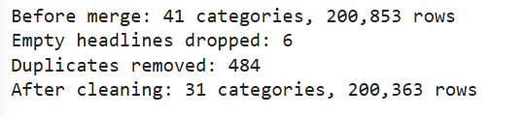
Figure 5. Description of the HuffPost dataset following data cleaning
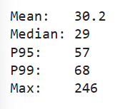
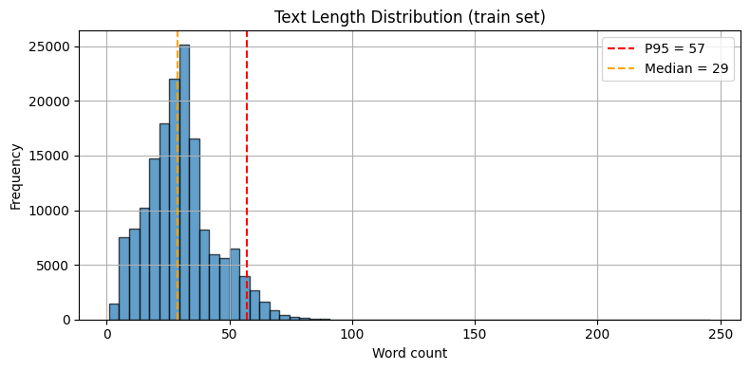
Figure 6. Bar chart of text length distribution of the HuffPost dataset
Figure 7. Statistics for the text distribution of the HuffPost dataset

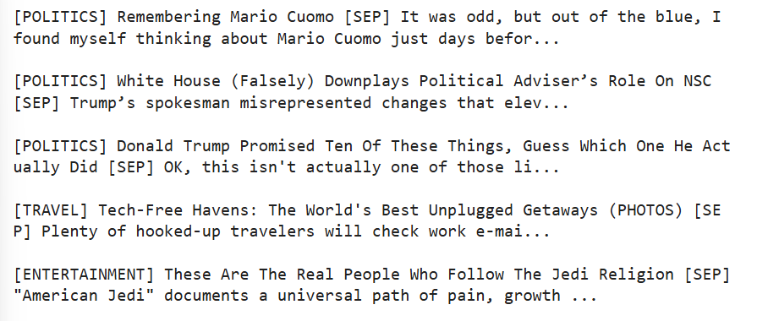
Figure 8. Sample examples from the HuffPost dataset following cleaning

Appendix B - Class by Class evaluation metrics

Table 2. DistilBERT Classification Report (Test Set)
Class | Precision | Recall | F1-Score | Support
ARTS | 0.5617 | 0.6804 | 0.6154 | 388
BLACK VOICES | 0.4598 | 0.5298 | 0.4923 | 453
BUSINESS | 0.4992 | 0.5303 | 0.5143 | 594
COMEDY | 0.4974 | 0.5513 | 0.5229 | 517
CRIME | 0.5127 | 0.7147 | 0.5971 | 340
DIVORCE | 0.7436 | 0.8480 | 0.7923 | 342
EDUCATION | 0.4045 | 0.6698 | 0.5044 | 215
ENTERTAINMENT | 0.7929 | 0.6220 | 0.6971 | 1606
ENVIRONMENT | 0.5279 | 0.6726 | 0.5915 | 394
FIFTY | 0.2475 | 0.5286 | 0.3371 | 140
FOOD & DRINK | 0.8358 | 0.8257 | 0.8307 | 832
GOOD NEWS | 0.3318 | 0.5108 | 0.4023 | 139
HOME & LIVING | 0.6950 | 0.5207 | 0.5954 | 1085
IMPACT | 0.3630 | 0.4261 | 0.3920 | 345
LATINO VOICES | 0.2604 | 0.6106 | 0.3651 | 113
MEDIA | 0.4173 | 0.7544 | 0.5374 | 281
MONEY | 0.4339 | 0.7529 | 0.5505 | 170
PARENTING | 0.7929 | 0.6558 | 0.7178 | 1255
POLITICS | 0.9150 | 0.5691 | 0.7017 | 3272
QUEER VOICES | 0.7785 | 0.7132 | 0.7444 | 631
RELIGION | 0.4887 | 0.7677 | 0.5972 | 254
SCIENCE | 0.4870 | 0.6881 | 0.5703 | 218
SPORTS | 0.7002 | 0.7546 | 0.7264 | 489
STYLE | 0.8448 | 0.8376 | 0.8412 | 1176
TECH | 0.3349 | 0.7094 | 0.4550 | 203
TRAVEL | 0.8215 | 0.8332 | 0.8273 | 989
WEDDINGS | 0.7979 | 0.8329 | 0.8150 | 365
WEIRD NEWS | 0.3502 | 0.6217 | 0.4480 | 267
WELLNESS | 0.7712 | 0.6734 | 0.7190 | 1782
WOMEN | 0.3055 | 0.4735 | 0.3714 | 340
WORLD NEWS | 0.7500 | 0.7268 | 0.7382 | 842

